**REPORT**  
Dokumen Installasi - Redis

Contents

Ringkasan : 1

Redis server: 2

Topologi: 2

Persiapan 3

Sistem Operasi 3

Install paket: 3

Menambahkan grup dan user 3

Buat redis group: 3

Buat redis user: 3

Optimisasi Sistem Operasi 3

• Networking optimization 3

• Memory-related kernel parameters 3

Install redis server 4

Unduh dan install: 4

Cek installasi redis: 4

Cek versi redis-server: 4

Buat direktori kerja: 4

Redis-cluster 6

Log-rotate 7

Script: 7

dc-redis-cl-01 8

Konfigurasi redis 8

Master.conf 8

Slave.conf 8

Script 8

System cek 10

Cek overcomit: 10

Cek network: 10

Redis cek 10

Cek versi redis: 10

Cek status service redis: 10

Cek openport 11

Cek replica info 11

Cek cluster info 12

Cek node cluster 12

Cek logrotate 12

dc-redis-cl-02 14

Konfigurasi redis 14

Master.conf 14

Slave.conf 14

Script 14

System cek 16

Cek overcomit: 16

Cek network: 16

Redis cek 16

Cek versi redis: 16

Cek status service redis: 16

Cek openport 17

Cek replica info 17

Cek cluster info 18

Cek node cluster 18

Cek logrotate 18

dc-redis-cl-03 20

Konfigurasi redis 20

Master.conf 20

Slave.conf 20

Script 20

System cek 22

Cek overcomit: 22

Cek network: 22

Redis cek 22

Cek versi redis 22

Cek status redis service: 22

Cek openport 23

Cek replica info 23

Cek cluster info 24

Cek node cluster 24

Cek logrotate 24

drc-redis-cl-01 26

Konfigurasi redis 26

Master.conf 26

Slave.conf 26

Script 26

System cek 28

Cek overcomit: 28

Cek network: 28

Redis cek 28

Cek versi redis 28

Cek status redis service: 28

Cek openport 29

Cek replica info 29

Cek cluster info 30

Cek node cluster 30

Cek logrotate 31

drc-redis-cl-02 32

Konfigurasi redis 32

Master.conf 32

Slave.conf 32

Script 32

System cek 34

Cek overcomit: 34

Cek network: 34

Redis cek 34

Cek versi redis 34

Cek status redis service: 34

Cek openport 35

Cek replica info 35

Cek cluster info 36

Cek node cluster 36

Cek logrotate 36

drc-redis-cl-03 37

Konfigurasi redis 37

Master.conf 37

Slave.conf 37

Script 38

System cek 39

Cek overcomit: 39

Cek network: 39

Redis cek 39

Cek versi redis 39

Cek status redis service: 40

Cek openport 40

Cek replica info 40

Cek cluster info 41

Cek node cluster 41

Cek logrotate 42

# Ringkasan :

* port node:

|  |  |  |
| --- | --- | --- |
|  | Master | Slave |
| DC | 172.28.200.235:7000 | 172.28.200.235:7001 |
| 172.28.200.236:7000 | 172.28.200.236:7001 |
| 172.28.200.237:7000 | 172.28.200.237:7001 |
|  |  |  |
| DRC | 172.28.100.235:7000 | 172.28.100.235:7001 |
| 172.28.100.236:7000 | 172.28.100.236:7001 |
| 172.28.100.237:7000 | 172.28.100.237:7001 |

* Password:
* Masterauth : SomePassw0rd
* Requirepass : SomePassw0rd

# Redis server:

Redis adalah penyimpanan struktur data dalam memori open-source yang unggul dalam caching. Database non-relasional, Redis dikenal dengan fleksibilitas, kinerja, skalabilitas, dan dukungan bahasa yang luas.

## Topologi:

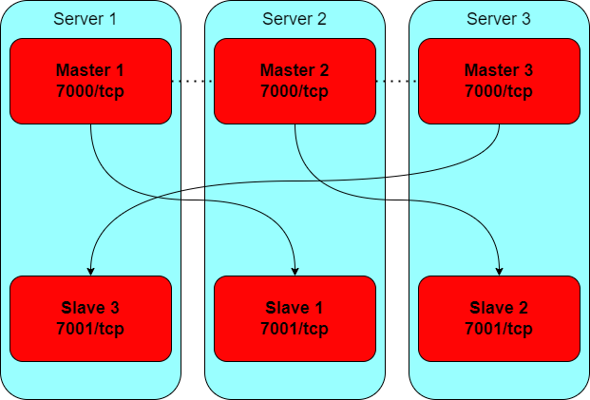

Deskripsi:

Klaster redis akan dimuat pada 2 site yaitu DC dan DRC. Klaster redis setiap site terdiri dari masing- masing 3 host. Masing-masing host memiliki sepasang node yaitu node Master dengan port 7000 dan node Slave dengan port 7001. Setiap node Master dihubungkan dan direplikasi dengan node Slave pada host yang berbeda secara silang. Hubungan antar node akan digambarkan seperti tabel berikut:

Tabel koneksi:



Tujuan:

Node Master direplikasi pada node Slave pada mesin berbeda untuk melanjutkan operasi ketika node mengalami kegagalan atau tidak dapat berkomunikasi dengan mesin lainnya. Klaster ini mampu untuk melanjutkan operasi saat beberapa node gagal atau tidak dapat berkomunikasi. Pada klaster ini batas kegagalan adalah 1 mesin server yang terdiri dari 1 node Master dan 1 node Slave. Namun, klaster akan menjadi tidak tersedia jika terjadi kegagalan yang lebih besar.

# Persiapan

## Sistem Operasi

### Install paket:

Instal paket tambahan yang dibutuhkan untuk melakukan kompilasi perangkat lunak redis server dari sumber dan untuk memantau ketersediaan layanan.

|  |
| --- |
| dnf install -y tcl systemd-devel.x86_64 python3 nmap |

## Menambahkan grup dan user

Untuk menjalankan layanan redis-master dan redis-slave sebagai user non-root tanpa akses login untuk meningkatkan keamanan.

### Buat redis group:

|  |
| --- |
| groupadd redis |

### Buat redis user:

|  |
| --- |
| useradd -s /sbin/nologin --system -g redis redis |

## Optimisasi Sistem Operasi

Redis mensyaratkan dilakukannya sejumlah optimalisasi pada konfigurasi jaringan dan memori dari server sebagai berikut:

### Networking optimization

Edit file /etc/sysctl.conf:

|  |
| --- |
| vi /etc/sysctl.conf |

Tambahkan konfigurasi berikut:

|  |
| --- |
| # redis networking optimization  net.core.somaxconn=65535  net.ipv4.tcp_max_syn_backlog=65535 |

Simpan konfigurasi

### Memory-related kernel parameters

Edit file /etc/sysctl.conf:

|  |
| --- |
| vi /etc/sysctl.conf |

Tambahkan konfigurasi berikut:

|  |
| --- |
| # redis memory optimization  vm.overcommit_memory=1 |

Simpan konfigurasi

# Install redis server

## Unduh dan install:

|  |
| --- |
| wget https://download.redis.io/redis-stable.tar.gz  tar zxvf redis-stable.tar.gz  cd redis-stable  make  make test  make install |

Perintah-perintah di atas akan mengunduh, mengompilasi, dan memasang perangkat lunak Redis server serta pendukungnya.

## Cek installasi redis:

Untuk memastikan semua perangkat lunak dan pendukungnya sudah terpasang jalankan perintah-perintah berikut:

|  |
| --- |
| whereis redis-server  whereis redis-benchmark  whereis redis-cli |

## Cek versi redis-server:

Untuk mengetahui versi redis-server yang terpasang jalankan perintah berikut:

|  |
| --- |
| redis-server –version |

## Buat direktori kerja:

Persiapkan direktori kerja yang dibutuhkan oleh layanan redis yang akan dipasang

|  |
| --- |
| mkdir /opt/redis/config  mkdir /opt/redis/run  mkdir /opt/redis/log  mkdir/opt/redis/master  mkdir/opt/redis/slave  mkdir/opt/redis/script |

Set kepemilikan direktori konfigurasi:

|  |
| --- |
| chown redis:redis -R /opt/redis |

Persiapkan berkas konfigurasi untuk redis-master:

touch /opt/redis/config/master.conf

vi /opt/redis/config/master.conf

Konfigurasi master.conf bisa dilihat pada dokumentasi untuk tiap-tiap node

Persiapkan berkas konfigurasi service untuk redis-master:

touch /etc/systemd/system/redis-master.service

vi /etc/systemd/system/redis-master.service

Konfigurasi redis-master.service

[Unit]

Description=Redis data structure server - redis-master

Documentation=https://redis.io/documentation

AssertPathExists=/opt/redis/master

AssertPathExists=/opt/redis/config/master.conf

[Service]

ExecStart=/usr/local/bin/redis-server /opt/redis/config/master.conf

LimitNOFILE=10032

NoNewPrivileges=yes

Type=notify

TimeoutStartSec=300

TimeoutStopSec=300

UMask=0077

User=redis

Group=redis

WorkingDirectory=/opt/redis/master

Restart=on-failure

RestartSec=5

[Install]

WantedBy=multi-user.target

Lakukan pemuatan service baru

systemctl daemon-reload

Jalankan service master

systemctl start redis-master.service

Aktifkan pemuatan otomatis master

systemctl enable redis-master.service

Cek status redis master

systemctl status redis-master.service

Persiapkan berkas konfigurasi untuk redis-slave:

touch /opt/redis/config/slave.conf

vi /opt/redis/config/slave.conf

Konfigurasi redis-slave.service

|  |
| --- |
| [Unit]  Description=Redis data structure server - redis-slave  Documentation=https://redis.io/documentation  AssertPathExists=/opt/redis/slave  AssertPathExists=/opt/redis/config/slave.conf  [Service]  ExecStart=/usr/local/bin/redis-server /opt/redis/config/slave.conf  LimitNOFILE=10032  NoNewPrivileges=yes  Type=notify  TimeoutStartSec=300  TimeoutStopSec=300  UMask=0077  User=redis  Group=redis  WorkingDirectory=/opt/redis/slave  Restart=on-failure  RestartSec=5  [Install]  WantedBy=multi-user.target |

Jalankan service slave

systemctl start redis-slave.service

Aktifkan pemuatan otomatis slave

systemctl enable redis-slave.service

Cek status redis slave

systemctl status redis-slave.service

lakukan pada semua server.

## Redis-cluster

NOTES:

Jika semua node sudah berjalan langkah selanjutnya adalah membentuk replikasi master-slave dan memasukkan semua node ke dalam sebuah klaster

Untuk membentuk replikasi master - slave dari node-node yang tersedia dan menyatukan semua node kedalam sebuah kluster gunakan perintah

redis-cli --cluster create <node_ip>:<node:port> ... --cluster-replicas 1

redis-cli --cluster create 172.28.100.235:7000 172.28.100.236:7000 172.28.100.237:7000 172.28.100.235:7001 172.28.100.236:7001 172.28.100.237:7001 --cluster-replicas 1

Opsi --cluster-replicas 1 berarti kita menginginkan sebuah slave untuk setiap master yang dibuat.

## Log-rotate

Install paket logrotate

|  |
| --- |
| dnf install logrotate -y |

Aplikasi logrotate digunakan untuk manajemen berkas log dari aplikasi redis. Persiapkan berkas konfigurasi untuk log rotate:

vi /etc/logrotate.conf

konfigurasi logrotate.conf

# redis-master

/opt/redis/log/master.log {

daily

missingok

rotate 14

compress

create 0664 redis redis

}

# redis-slave

/opt/redis/log/slave.log {

daily

missingok

rotate 14

compress

create 0664 redis redis

}

Penjadwalan aplikasi logrotate untuk melakukan rotasi berkas log secara harian dilakukan dengan menggunakan aplikasi sistem crontab:

crontab -e

tambahkan perintah berikut:

|  |
| --- |
| * 0 * * * /usr/sbin/logrotate /etc/logrotate.conf |

Konfigurasi untuk setiap masing-masing dapat dilihat pada dokumentasi installasi per server

## Script:

Script recycle.sh digunakan untuk mengembalikan kondisi ideal master - slave pada setiap server pada sebuah kluster redis pada kondisi semua server normal setelah terjadinya kegagalan pada salah satu server. Script ini dijadwalkan untuk berjalan secara berkala dengan menggunakan aplikasi sistem crontab:

crontab -e

tambahkan perintah berikut:

|  |
| --- |
| */15 * * * * /opt/redis/script/recycle.sh >> /opt/redis/log/recycle.log |

Konfigurasi untuk setiap masing-masing dapat dilihat pada dokumentasi installasi per server.

# dc-redis-cl-01

## Konfigurasi redis

### Master.conf

|  |
| --- |
| Bind 127.0.0.1 172.28.200.235  port 7000  protected-mode no  supervised auto  pidfile /opt/redis/run/master.pid  dir /opt/redis/master  cluster-enabled yes  cluster-node-timeout 5000  loglevel verbose  logfile /opt/redis/log/master.log  requirepass SomePassw0rd  # masterauth SomePassw0rd |

### Slave.conf

|  |
| --- |
| bind 127.0.0.1 172.28.200.235  protected-mode no  port 7001  supervised auto  pidfile /opt/redis/run/slave.pid  logfile /opt/redis/log/slave.log  dir /opt/redis/slave  cluster-enabled yes  cluster-config-file nodes.conf  cluster-node-timeout 5000 |

## Script

#!/bin/bash

host_ip=172.28.200.235

master_port=7000

slave_port=7001

master_service_name=redis-master

slave_service_name=redis-slave

my_master_ip=172.28.200.237

my_master_port=7000

master_auth=SomePassw0rd

echo "$(date) - INFO: recycle script started"

slave_nmap=$(nmap -p $slave_port $host_ip | grep $slave_port'/tcp')

if [[ $slave_nmap == *"open"* ]]; then

  master_nmap=$(nmap -p $master_port $host_ip | grep $master_port'/tcp')

  if [[ $master_nmap == *"open"* ]]; then

    master_role=$(/usr/local/bin/redis-cli --no-auth-warning -h $host_ip -p $master_port -a $master_auth info replication | grep role)

    slave_role=$(/usr/local/bin/redis-cli --no-auth-warning -h $host_ip -p $slave_port -a $master_auth info replication | grep role)

    if [[ $slave_role == *"master"* ]] && [[ $master_role == *"master"* ]]

    then

      # echo "situasi berbahaya!"

      echo $(date) - INFO: node slave is master, cek its master status

      my_master_nmap=$(nmap -p $my_master_port $my_master_ip | grep $my_master_port'/tcp')

      if [[ $my_master_nmap == *"open"* ]]; then

        # echo "aman untuk lanjut"

        echo $(date) - INFO: node master of node slave is alive, cek its role

        my_master_role=$(/usr/local/bin/redis-cli --no-auth-warning -h $my_master_ip -p $my_master_port -a $master_auth info replication | grep role)

        if [[ $my_master_role == *"slave"* ]]; then

          # echo "hentikan service redis-slave"

          echo $(date) - INFO: node master of node slave is slave, recycle

          /usr/bin/systemctl stop $slave_service_name

          while [[ $my_master_role == *"slave"* ]]

          do

            # echo "tunggu master aktif"

            echo $(date) - INFO: recycling

            sleep 5

            my_master_role=$(/usr/local/bin/redis-cli --no-auth-warning -h $my_master_ip -p $my_master_port -a $master_auth info replication | grep role)

          done

          # echo "jalankan kembali service redis-slave"

          echo $(date) - INFO: recycled

          /usr/bin/systemctl start $slave_service_name

        fi

      else

        # echo "tidak aman untuk lanjut"

        echo $(date) - INFO: node master of node slave is down, cannot continue

      fi

    else

      # echo "situasi aman"

      echo $(date) - INFO: all good, nothing to do

    fi

  else

    # host is up, node master is down

    echo $(date) - INFO: node master is down, cannot continue

  fi

else

  # host is up, node slave is down

  echo $(date) - INFO: node slave is down, cannot continue

fi

echo $(date) - INFO: recycle script ended

chmod 0660 /opt/redis/log/recycle.log

## System cek

### Cek overcomit:

|  |
| --- |
| sysctl vm.overcommit_memory vm.swappiness |

Output:

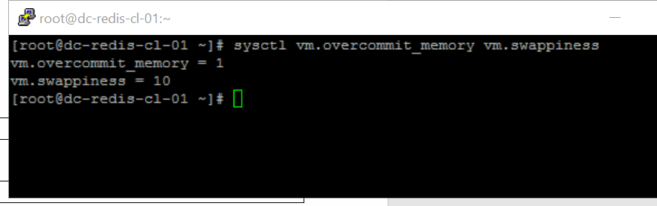

### Cek network:

|  |
| --- |
| sysctl net.core.somaxconn net.ipv4.tcp_max_syn_backlog |

Output:

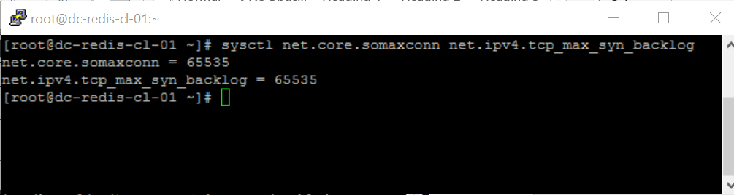

## Redis cek

### Cek versi redis:

|  |
| --- |
| redis-server --version |

Ouput:

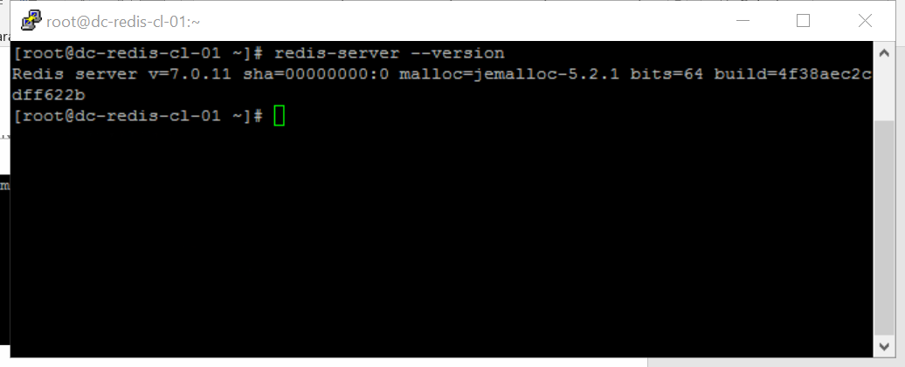

### Cek status service redis:

|  |
| --- |
| systemctl status redis-master.service  systemctl status redis-slave.service |

Output:

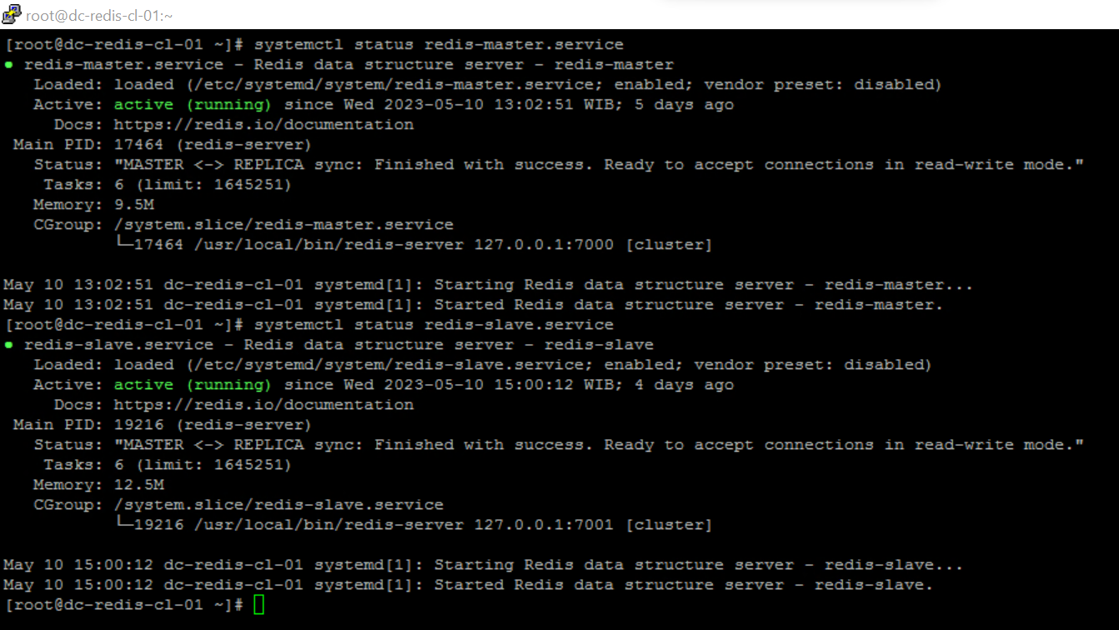



### Cek openport

ss -tunlp | grep :7000  
ss -tunlp | grep :7001

Output:

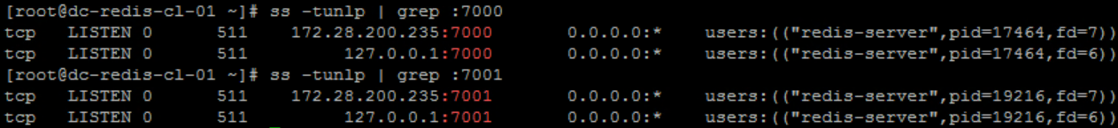

### Cek replica info

redis-cli -p 7000 -a SomePassw0rd info replication

redis-cli -p 7001 -a SomePassw0rd info replication

Output:

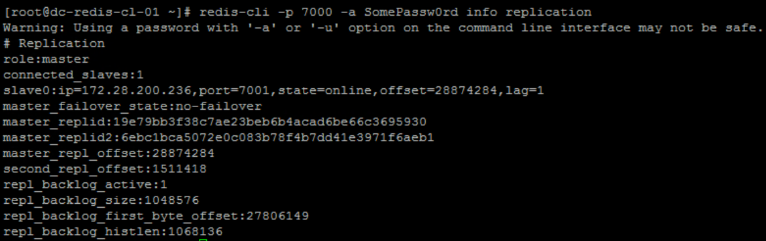

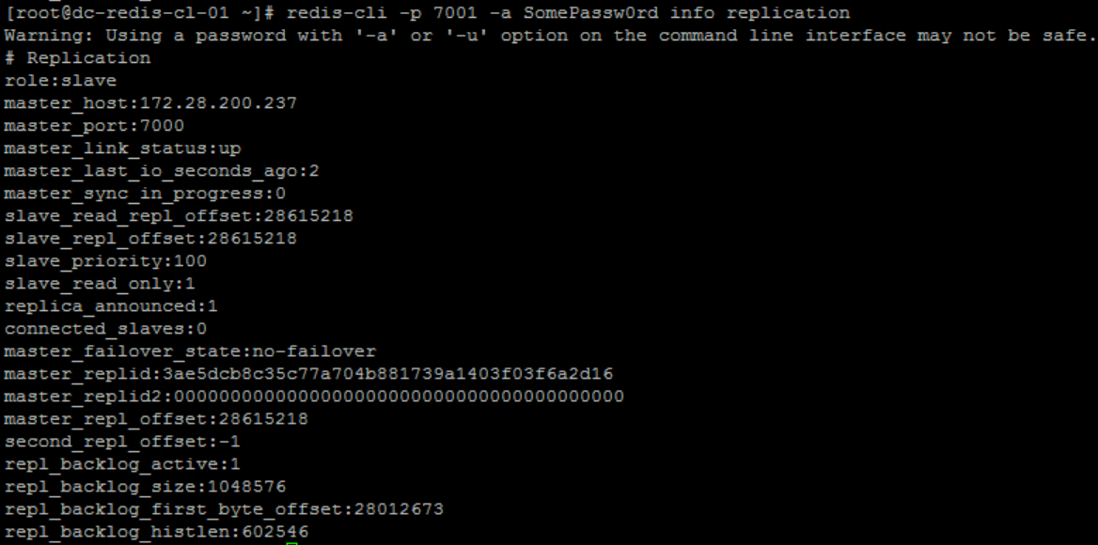

### Cek cluster info

redis-cli -p 7000 -a SomePassw0rd info cluster

redis-cli -p 7001 -a SomePassw0rd info cluster

Output:

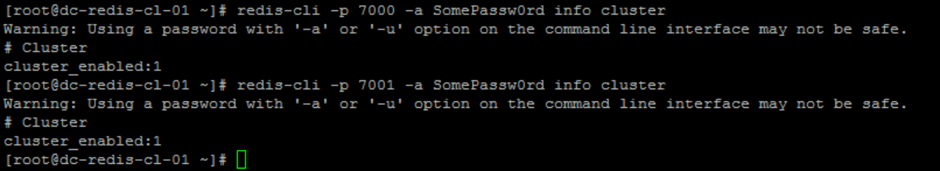

### Cek node cluster

redis-cli -p 7000 -a SomePassw0rd cluster nodes

redis-cli -p 7001 -a SomePassw0rd cluster nodes

Output:

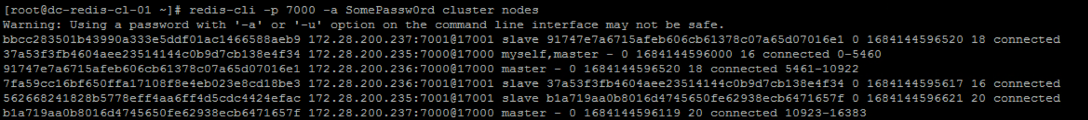

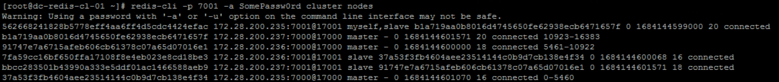

## Cek logrotate

logrotate /etc/logrotate.conf --debug

Output:

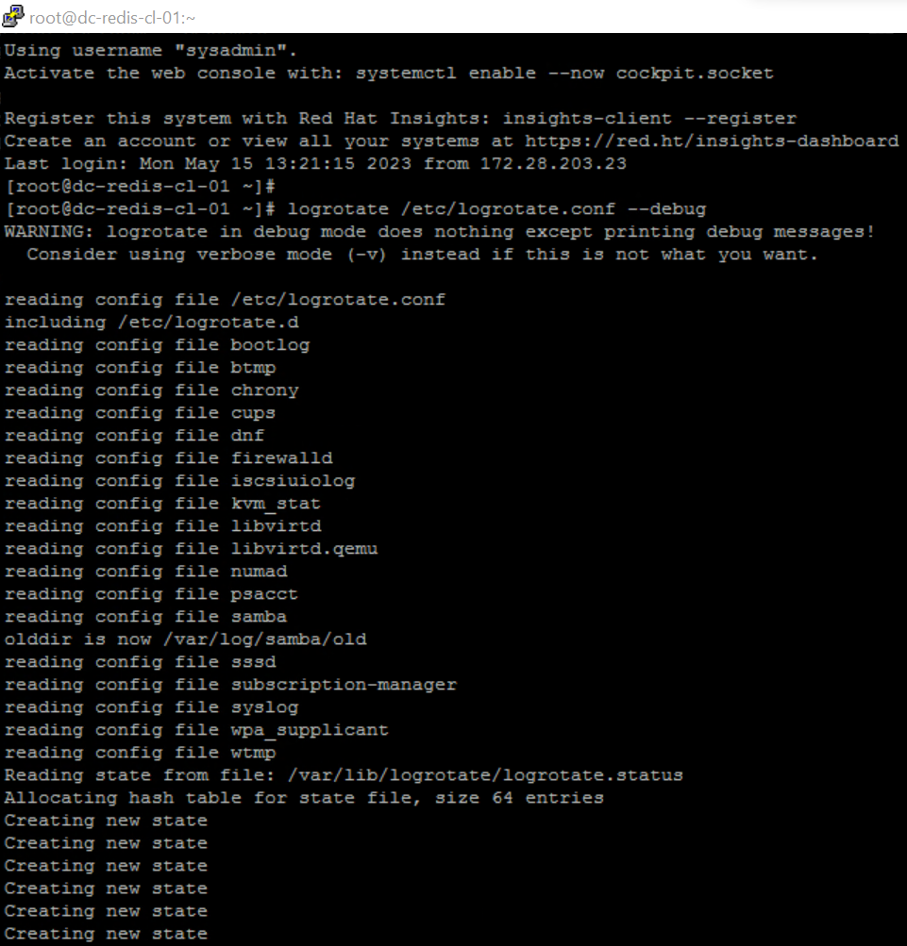

# dc-redis-cl-02

## Konfigurasi redis

### Master.conf

|  |
| --- |
| Bind 127.0.0.1 172.28.200.236  port 7000  protected-mode no  supervised auto  pidfile /opt/redis/run/master.pid  dir /opt/redis/master  cluster-enabled yes  cluster-node-timeout 5000  loglevel verbose  logfile /opt/redis/log/master.log  requirepass SomePassw0rd  # masterauth SomePassw0rd |

### Slave.conf

|  |
| --- |
| bind 127.0.0.1 172.28.200.236  protected-mode no  port 7001  supervised auto  pidfile /opt/redis/run/slave.pid  logfile /opt/redis/log/slave.log  dir /opt/redis/slave  cluster-enabled yes  cluster-config-file nodes.conf  cluster-node-timeout 5000 |

## Script

#!/bin/bash

host_ip=172.28.200.236

master_port=7000

slave_port=7001

master_service_name=redis-master

slave_service_name=redis-slave

my_master_ip=172.28.200.235

my_master_port=7000

master_auth=SomePassw0rd

echo "$(date) - INFO: recycle script started"

slave_nmap=$(nmap -p $slave_port $host_ip | grep $slave_port'/tcp')

if [[ $slave_nmap == *"open"* ]]; then

  master_nmap=$(nmap -p $master_port $host_ip | grep $master_port'/tcp')

  if [[ $master_nmap == *"open"* ]]; then

    master_role=$(/usr/local/bin/redis-cli --no-auth-warning -h $host_ip -p $master_port -a $master_auth info replication | grep role)

    slave_role=$(/usr/local/bin/redis-cli --no-auth-warning -h $host_ip -p $slave_port -a $master_auth info replication | grep role)

    if [[ $slave_role == *"master"* ]] && [[ $master_role == *"master"* ]]

    then

      # echo "situasi berbahaya!"

      echo $(date) - INFO: node slave is master, cek its master status

      my_master_nmap=$(nmap -p $my_master_port $my_master_ip | grep $my_master_port'/tcp')

      if [[ $my_master_nmap == *"open"* ]]; then

        # echo "aman untuk lanjut"

        echo $(date) - INFO: node master of node slave is alive, cek its role

        my_master_role=$(/usr/local/bin/redis-cli --no-auth-warning -h $my_master_ip -p $my_master_port -a $master_auth info replication | grep role)

        if [[ $my_master_role == *"slave"* ]]; then

          # echo "hentikan service redis-slave"

          echo $(date) - INFO: node master of node slave is slave, recycle

          /usr/bin/systemctl stop $slave_service_name

          while [[ $my_master_role == *"slave"* ]]

          do

            # echo "tunggu master aktif"

            echo $(date) - INFO: recycling

            sleep 5

            my_master_role=$(/usr/local/bin/redis-cli --no-auth-warning -h $my_master_ip -p $my_master_port -a $master_auth info replication | grep role)

          done

          # echo "jalankan kembali service redis-slave"

          echo $(date) - INFO: recycled

          /usr/bin/systemctl start $slave_service_name

        fi

      else

        # echo "tidak aman untuk lanjut"

        echo $(date) - INFO: node master of node slave is down, cannot continue

      fi

    else

      # echo "situasi aman"

      echo $(date) - INFO: all good, nothing to do

    fi

  else

    # host is up, node master is down

    echo $(date) - INFO: node master is down, cannot continue

  fi

else

  # host is up, node slave is down

  echo $(date) - INFO: node slave is down, cannot continue

fi

echo $(date) - INFO: recycle script ended

chmod 0660 /opt/redis/log/recycle.log

## System cek

### Cek overcomit:

|  |
| --- |
| sysctl vm.overcommit_memory vm.swappiness |

Output:

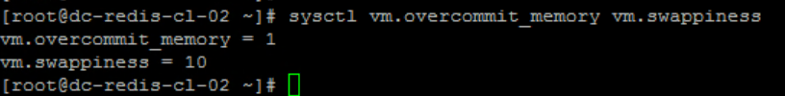

### Cek network:

|  |
| --- |
| sysctl net.core.somaxconn net.ipv4.tcp_max_syn_backlog |

Output:

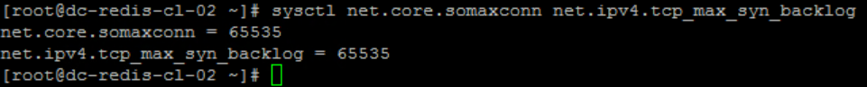

## Redis cek

### Cek versi redis:

|  |
| --- |
| redis-server --version |

Ouput:



### Cek status service redis:

|  |
| --- |
| systemctl status redis-master.service  systemctl status redis-slave.service |

Output:

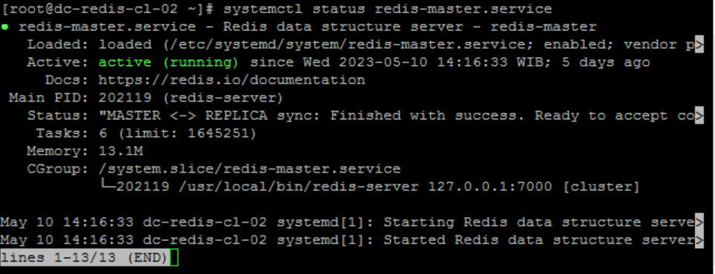

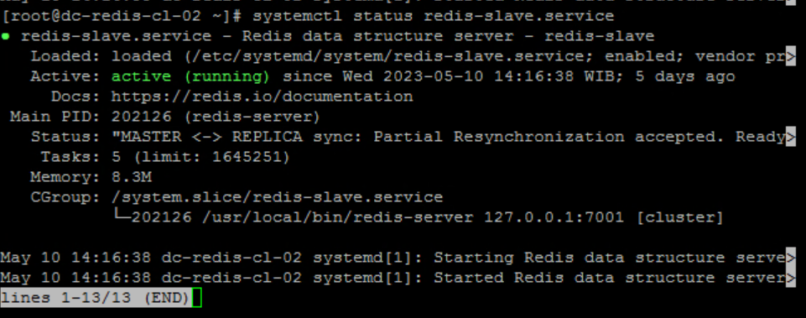

### Cek openport

ss -tunlp | grep :7000

ss -tunlp | grep :7001

Output:

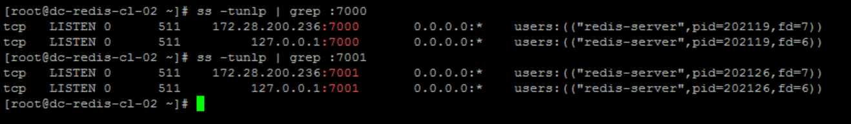

### Cek replica info

redis-cli -p 7000 -a SomePassw0rd info replication

redis-cli -p 7001 -a SomePassw0rd info replication

Output:

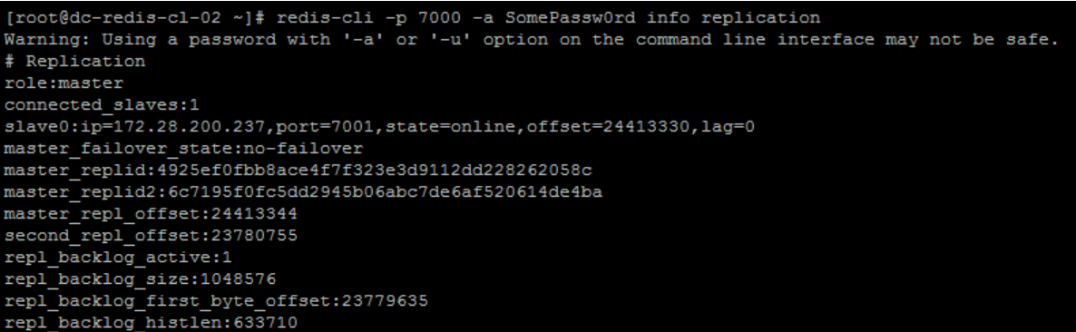

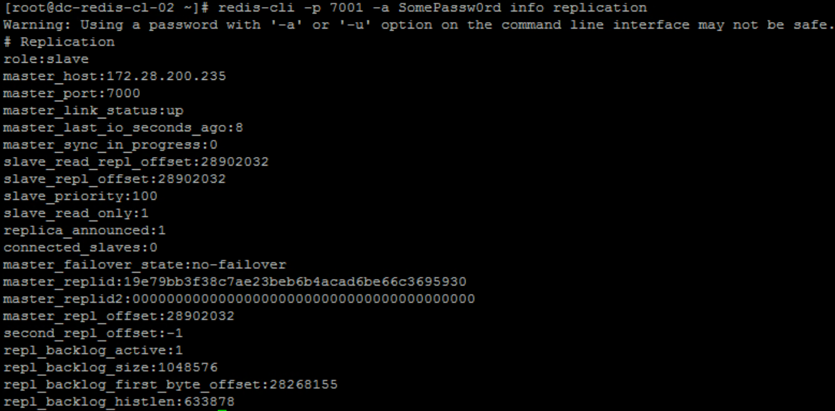

### Cek cluster info

redis-cli -p 7000 -a SomePassw0rd info cluster

redis-cli -p 7001 -a SomePassw0rd info cluster

Output:





### Cek node cluster

redis-cli -p 7000 -a SomePassw0rd cluster nodes

redis-cli -p 7001 -a SomePassw0rd cluster nodes

Output

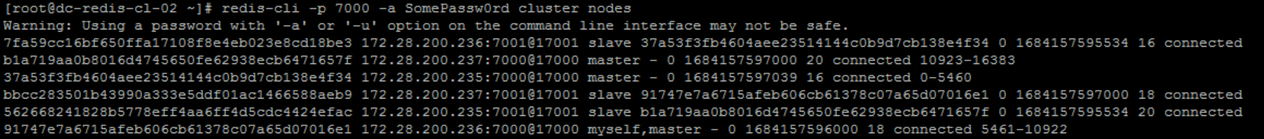

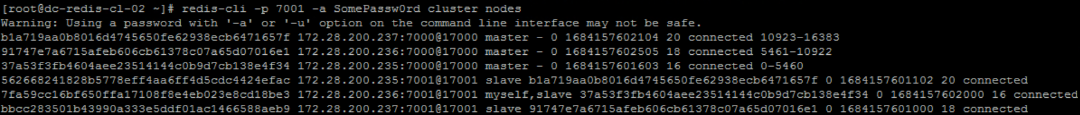

## Cek logrotate

logrotate /etc/logrotate.conf --debug

Output:

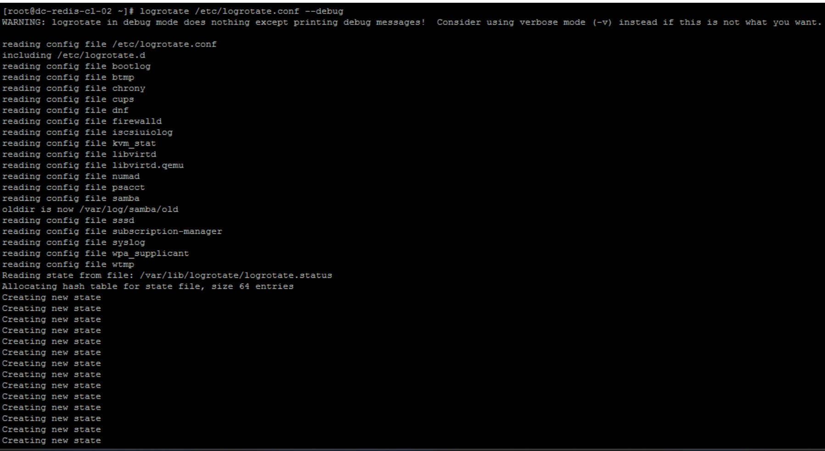

# dc-redis-cl-03

## Konfigurasi redis

### Master.conf

|  |
| --- |
| Bind 127.0.0.1 172.28.200.237  port 7000  protected-mode no  supervised auto  pidfile /opt/redis/run/master.pid  dir /opt/redis/master  cluster-enabled yes  cluster-node-timeout 5000  loglevel verbose  logfile /opt/redis/log/master.log  requirepass SomePassw0rd  # masterauth SomePassw0rd |

### Slave.conf

|  |
| --- |
| bind 127.0.0.1 172.28.200.237  protected-mode no  port 7001  supervised auto  pidfile /opt/redis/run/slave.pid  logfile /opt/redis/log/slave.log  dir /opt/redis/slave  cluster-enabled yes  cluster-config-file nodes.conf  cluster-node-timeout 5000 |

## Script

#!/bin/bash

host_ip=172.28.200.237

master_port=7000

slave_port=7001

master_service_name=redis-master

slave_service_name=redis-slave

my_master_ip=172.28.200.236

my_master_port=7000

master_auth=SomePassw0rd

echo "$(date) - INFO: recycle script started"

slave_nmap=$(nmap -p $slave_port $host_ip | grep $slave_port'/tcp')

if [[ $slave_nmap == *"open"* ]]; then

  master_nmap=$(nmap -p $master_port $host_ip | grep $master_port'/tcp')

  if [[ $master_nmap == *"open"* ]]; then

    master_role=$(/usr/local/bin/redis-cli --no-auth-warning -h $host_ip -p $master_port -a $master_auth info replication | grep role)

    slave_role=$(/usr/local/bin/redis-cli --no-auth-warning -h $host_ip -p $slave_port -a $master_auth info replication | grep role)

    if [[ $slave_role == *"master"* ]] && [[ $master_role == *"master"* ]]

    then

      # echo "situasi berbahaya!"

      echo $(date) - INFO: node slave is master, cek its master status

      my_master_nmap=$(nmap -p $my_master_port $my_master_ip | grep $my_master_port'/tcp')

      if [[ $my_master_nmap == *"open"* ]]; then

        # echo "aman untuk lanjut"

        echo $(date) - INFO: node master of node slave is alive, cek its role

        my_master_role=$(/usr/local/bin/redis-cli --no-auth-warning -h $my_master_ip -p $my_master_port -a $master_auth info replication | grep role)

        if [[ $my_master_role == *"slave"* ]]; then

          # echo "hentikan service redis-slave"

          echo $(date) - INFO: node master of node slave is slave, recycle

          /usr/bin/systemctl stop $slave_service_name

          while [[ $my_master_role == *"slave"* ]]

          do

            # echo "tunggu master aktif"

            echo $(date) - INFO: recycling

            sleep 5

            my_master_role=$(/usr/local/bin/redis-cli --no-auth-warning -h $my_master_ip -p $my_master_port -a $master_auth info replication | grep role)

          done

          # echo "jalankan kembali service redis-slave"

          echo $(date) - INFO: recycled

          /usr/bin/systemctl start $slave_service_name

        fi

      else

        # echo "tidak aman untuk lanjut"

        echo $(date) - INFO: node master of node slave is down, cannot continue

      fi

    else

      # echo "situasi aman"

      echo $(date) - INFO: all good, nothing to do

    fi

  else

    # host is up, node master is down

    echo $(date) - INFO: node master is down, cannot continue

  fi

else

  # host is up, node slave is down

  echo $(date) - INFO: node slave is down, cannot continue

fi

echo $(date) - INFO: recycle script ended

chmod 0660 /opt/redis/log/recycle.log

## System cek

### Cek overcomit:

|  |
| --- |
| sysctl vm.overcommit_memory vm.swappiness |

Output:



### Cek network:

|  |
| --- |
| sysctl net.core.somaxconn net.ipv4.tcp_max_syn_backlog |

Output:



## Redis cek

### Cek versi redis

|  |
| --- |
| redis-server --version |

Ouput:



### Cek status redis service:

|  |
| --- |
| systemctl status redis-master.service  systemctl status redis-slave.service |

Output:

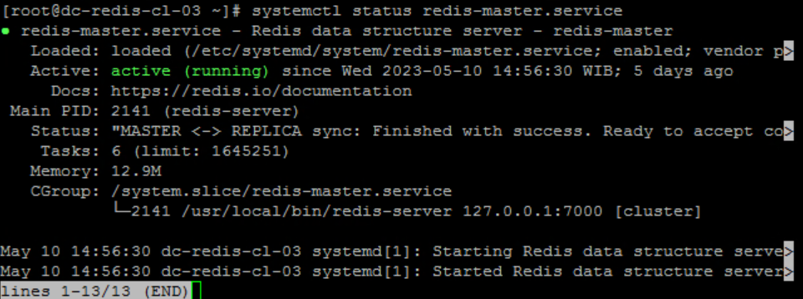

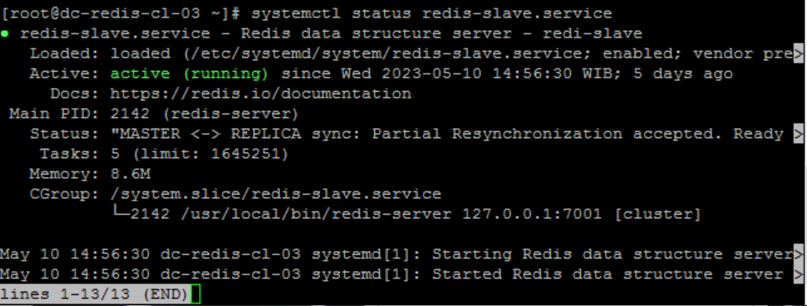

### Cek openport

ss -tunlp | grep :7000

ss -tunlp | grep :7001

Output:

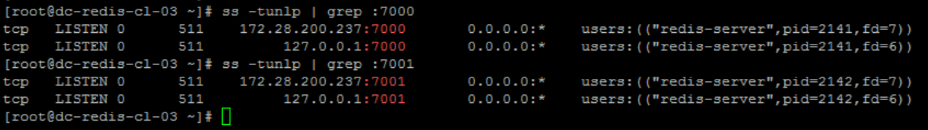

### Cek replica info

redis-cli -p 7000 -a SomePassw0rd info replication

redis-cli -p 7001 -a SomePassw0rd info replication

Output:

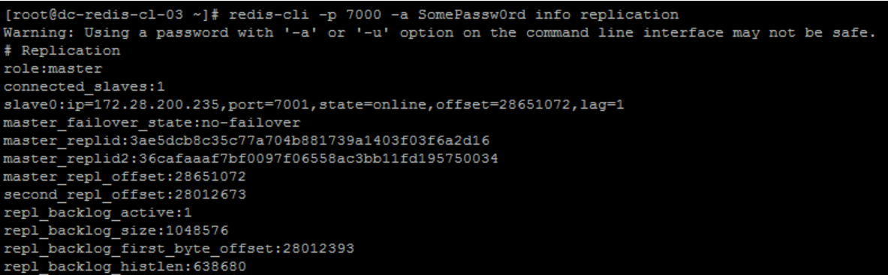

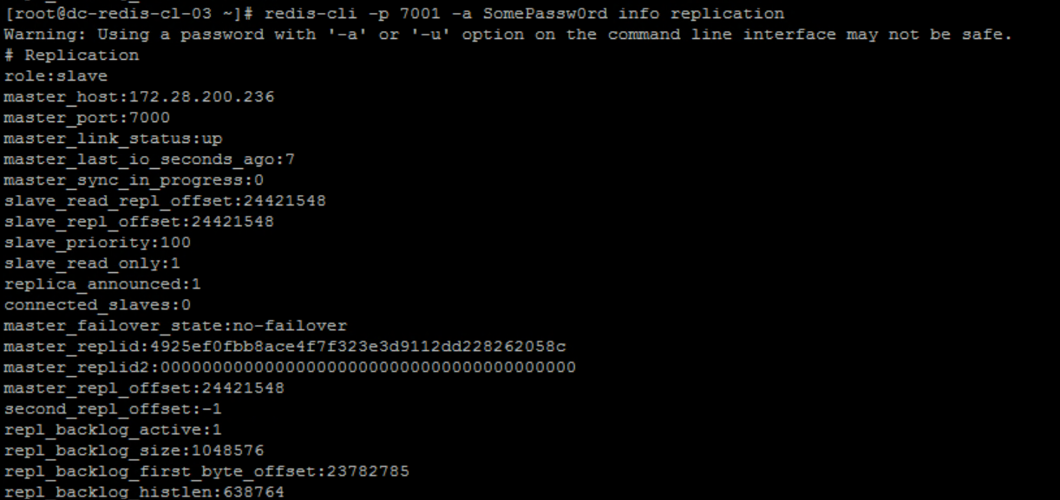

### Cek cluster info

redis-cli -p 7000 -a SomePassw0rd info cluster

redis-cli -p 7001 -a SomePassw0rd info cluster

Output:





### Cek node cluster

redis-cli -p 7000 -a SomePassw0rd cluster nodes

redis-cli -p 7001 -a SomePassw0rd cluster nodes

Output:

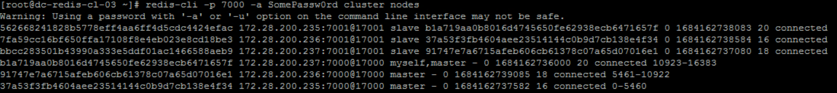

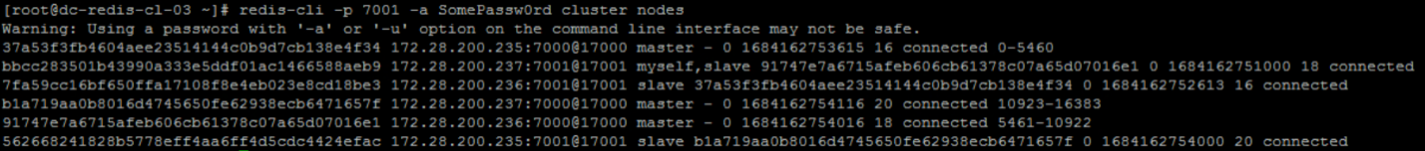

## Cek logrotate

logrotate /etc/logrotate.conf --debug

Output:

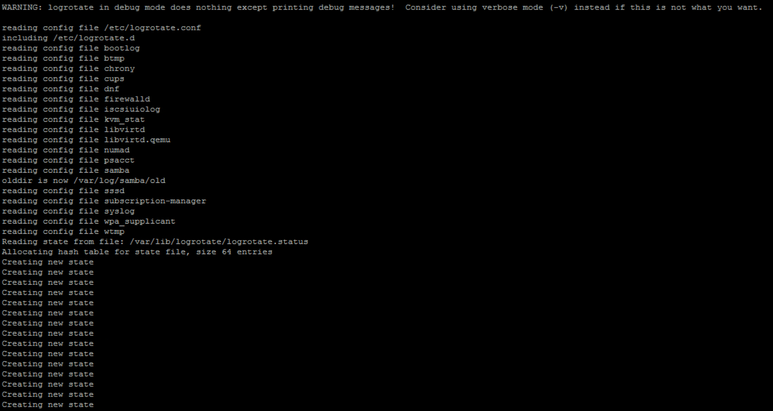

drc-redis-cl-01

Konfigurasi redis

Master.conf

|  |
| --- |
| Bind 127.0.0.1 172.28.100.235  port 7000  protected-mode no  supervised auto  pidfile /opt/redis/run/master.pid  dir /opt/redis/master  cluster-enabled yes  cluster-node-timeout 5000  loglevel verbose  logfile /opt/redis/log/master.log  requirepass SomePassw0rd  # masterauth SomePassw0rd |

Slave.conf

|  |
| --- |
| bind 127.0.0.1 172.28.100.235  protected-mode no  port 7001  supervised auto  pidfile /opt/redis/run/slave.pid  logfile /opt/redis/log/slave.log  dir /opt/redis/slave  cluster-enabled yes  cluster-config-file nodes.conf  cluster-node-timeout 5000 |

Script

#!/bin/bash

host_ip=172.28.100.235

master_port=7000

slave_port=7001

master_service_name=redis-master

slave_service_name=redis-slave

my_master_ip=172.28.100.237

my_master_port=7000

master_auth=SomePassw0rd

echo "$(date) - INFO: recycle script started"

slave_nmap=$(nmap -p $slave_port $host_ip | grep $slave_port'/tcp')

if [[ $slave_nmap == *"open"* ]]; then

  master_nmap=$(nmap -p $master_port $host_ip | grep $master_port'/tcp')

  if [[ $master_nmap == *"open"* ]]; then

    master_role=$(/usr/local/bin/redis-cli --no-auth-warning -h $host_ip -p $master_port -a $master_auth info replication | grep role)

    slave_role=$(/usr/local/bin/redis-cli --no-auth-warning -h $host_ip -p $slave_port -a $master_auth info replication | grep role)

    if [[ $slave_role == *"master"* ]] && [[ $master_role == *"master"* ]]

    then

      # echo "situasi berbahaya!"

      echo $(date) - INFO: node slave is master, cek its master status

      my_master_nmap=$(nmap -p $my_master_port $my_master_ip | grep $my_master_port'/tcp')

      if [[ $my_master_nmap == *"open"* ]]; then

        # echo "aman untuk lanjut"

        echo $(date) - INFO: node master of node slave is alive, cek its role

        my_master_role=$(/usr/local/bin/redis-cli --no-auth-warning -h $my_master_ip -p $my_master_port -a $master_auth info replication | grep role)

        if [[ $my_master_role == *"slave"* ]]; then

          # echo "hentikan service redis-slave"

          echo $(date) - INFO: node master of node slave is slave, recycle

          /usr/bin/systemctl stop $slave_service_name

          while [[ $my_master_role == *"slave"* ]]

          do

            # echo "tunggu master aktif"

            echo $(date) - INFO: recycling

            sleep 5

            my_master_role=$(/usr/local/bin/redis-cli --no-auth-warning -h $my_master_ip -p $my_master_port -a $master_auth info replication | grep role)

          done

          # echo "jalankan kembali service redis-slave"

          echo $(date) - INFO: recycled

          /usr/bin/systemctl start $slave_service_name

        fi

      else

        # echo "tidak aman untuk lanjut"

        echo $(date) - INFO: node master of node slave is down, cannot continue

      fi

    else

      # echo "situasi aman"

      echo $(date) - INFO: all good, nothing to do

    fi

  else

    # host is up, node master is down

    echo $(date) - INFO: node master is down, cannot continue

  fi

else

  # host is up, node slave is down

  echo $(date) - INFO: node slave is down, cannot continue

fi

echo $(date) - INFO: recycle script ended

chmod 0660 /opt/redis/log/recycle.log

System cek

### Cek overcomit:

|  |
| --- |
| sysctl vm.overcommit_memory vm.swappiness |

Output:

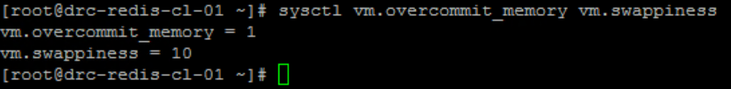

Cek network:

|  |
| --- |
| sysctl net.core.somaxconn net.ipv4.tcp_max_syn_backlog |

Output:

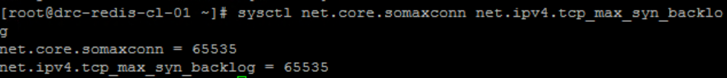

Redis cek

Cek versi redis

|  |
| --- |
| redis-server --version |

Ouput:



Cek status redis service:

|  |
| --- |
| systemctl status redis-master.service  systemctl status redis-slave.service |

Output:

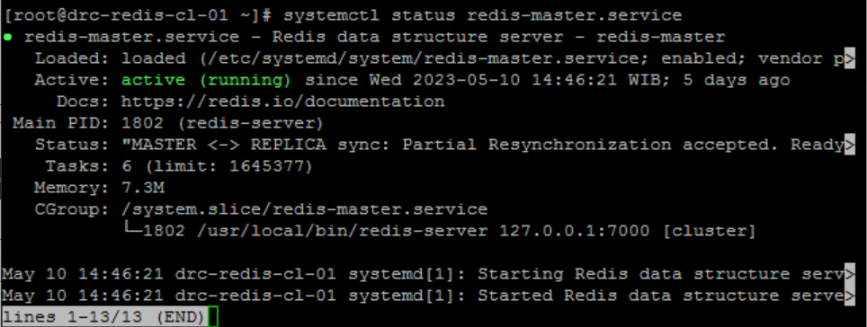

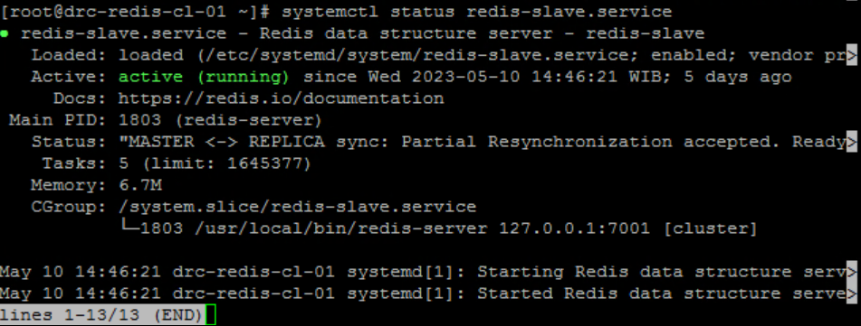

Cek openport

ss -tunlp | grep :7000

ss -tunlp | grep :7001

Output:

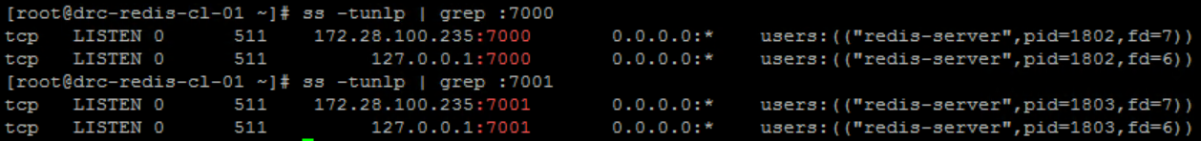

Cek replica info

redis-cli -p 7000 -a SomePassw0rd info replication

redis-cli -p 7001 -a SomePassw0rd info replication

Output:

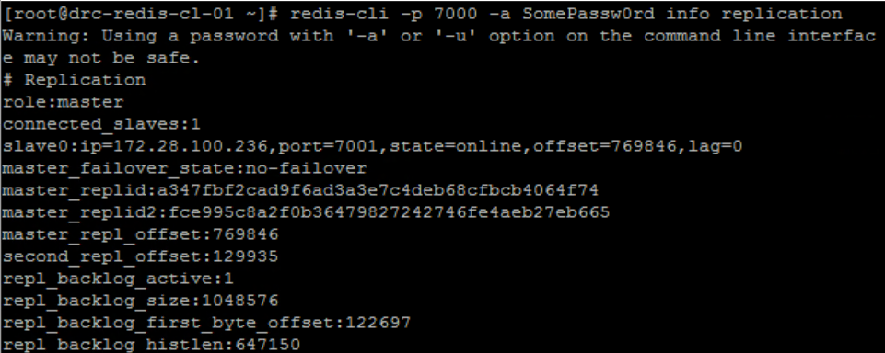

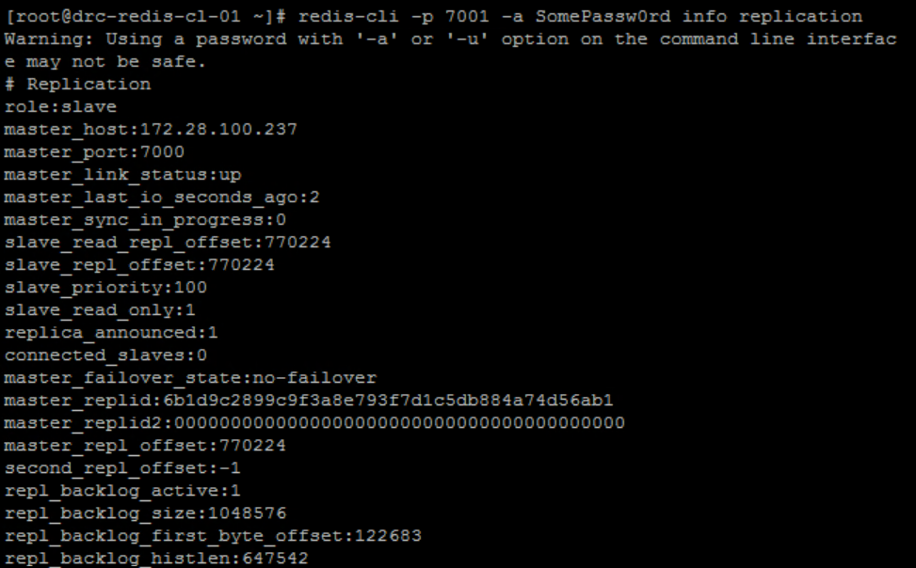

Cek cluster info

redis-cli -p 7000 -a SomePassw0rd info cluster

redis-cli -p 7001 -a SomePassw0rd info cluster

Output:

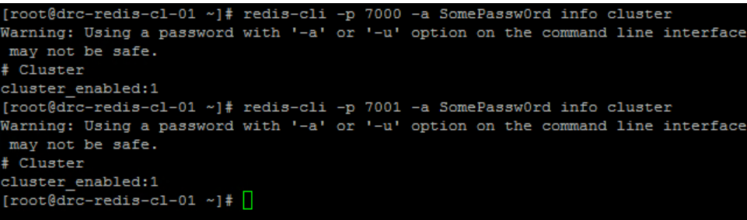

Cek node cluster

redis-cli -p 7000 -a SomePassw0rd cluster nodes

redis-cli -p 7001 -a SomePassw0rd cluster nodes

Output

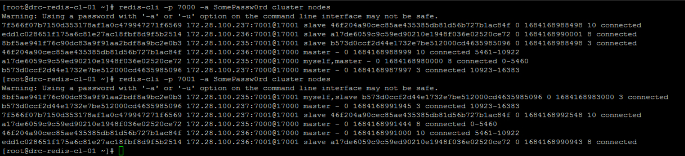

## Cek logrotate

logrotate /etc/logrotate.conf --debug

Output:

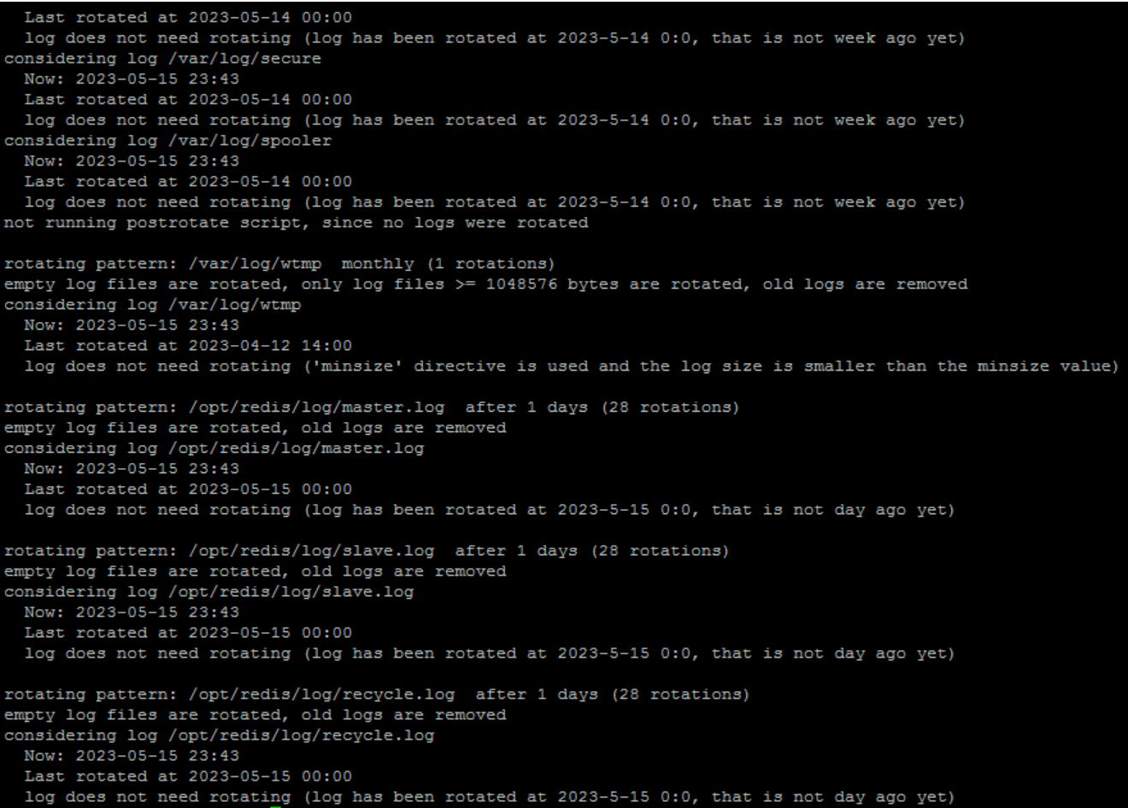

drc-redis-cl-02

Konfigurasi redis

Master.conf

|  |
| --- |
| Bind 127.0.0.1 172.28.100.236  port 7000  protected-mode no  supervised auto  pidfile /opt/redis/run/master.pid  dir /opt/redis/master  cluster-enabled yes  cluster-node-timeout 5000  loglevel verbose  logfile /opt/redis/log/master.log  requirepass SomePassw0rd  # masterauth SomePassw0rd |

Slave.conf

|  |
| --- |
| bind 127.0.0.1 172.28.100.236  protected-mode no  port 7001  supervised auto  pidfile /opt/redis/run/slave.pid  logfile /opt/redis/log/slave.log  dir /opt/redis/slave  cluster-enabled yes  cluster-config-file nodes.conf  cluster-node-timeout 5000 |

Script

#!/bin/bash

host_ip=172.28.100.236

master_port=7000

slave_port=7001

master_service_name=redis-master

slave_service_name=redis-slave

my_master_ip=172.28.100.235

my_master_port=7000

master_auth=SomePassw0rd

echo "$(date) - INFO: recycle script started"

slave_nmap=$(nmap -p $slave_port $host_ip | grep $slave_port'/tcp')

if [[ $slave_nmap == *"open"* ]]; then

  master_nmap=$(nmap -p $master_port $host_ip | grep $master_port'/tcp')

  if [[ $master_nmap == *"open"* ]]; then

    master_role=$(/usr/local/bin/redis-cli --no-auth-warning -h $host_ip -p $master_port -a $master_auth info replication | grep role)

    slave_role=$(/usr/local/bin/redis-cli --no-auth-warning -h $host_ip -p $slave_port -a $master_auth info replication | grep role)

    if [[ $slave_role == *"master"* ]] && [[ $master_role == *"master"* ]]

    then

      # echo "situasi berbahaya!"

      echo $(date) - INFO: node slave is master, cek its master status

      my_master_nmap=$(nmap -p $my_master_port $my_master_ip | grep $my_master_port'/tcp')

      if [[ $my_master_nmap == *"open"* ]]; then

        # echo "aman untuk lanjut"

        echo $(date) - INFO: node master of node slave is alive, cek its role

        my_master_role=$(/usr/local/bin/redis-cli --no-auth-warning -h $my_master_ip -p $my_master_port -a $master_auth info replication | grep role)

        if [[ $my_master_role == *"slave"* ]]; then

          # echo "hentikan service redis-slave"

          echo $(date) - INFO: node master of node slave is slave, recycle

          /usr/bin/systemctl stop $slave_service_name

          while [[ $my_master_role == *"slave"* ]]

          do

            # echo "tunggu master aktif"

            echo $(date) - INFO: recycling

            sleep 5

            my_master_role=$(/usr/local/bin/redis-cli --no-auth-warning -h $my_master_ip -p $my_master_port -a $master_auth info replication | grep role)

          done

          # echo "jalankan kembali service redis-slave"

          echo $(date) - INFO: recycled

          /usr/bin/systemctl start $slave_service_name

        fi

      else

        # echo "tidak aman untuk lanjut"

        echo $(date) - INFO: node master of node slave is down, cannot continue

      fi

    else

      # echo "situasi aman"

      echo $(date) - INFO: all good, nothing to do

    fi

  else

    # host is up, node master is down

    echo $(date) - INFO: node master is down, cannot continue

  fi

else

  # host is up, node slave is down

  echo $(date) - INFO: node slave is down, cannot continue

fi

echo $(date) - INFO: recycle script ended

chmod 0660 /opt/redis/log/recycle.log

System cek

### Cek overcomit:

|  |
| --- |
| sysctl vm.overcommit_memory vm.swappiness |

Output:

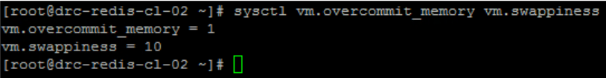

Cek network:

|  |
| --- |
| sysctl net.core.somaxconn net.ipv4.tcp_max_syn_backlog |

Output:



Redis cek

Cek versi redis

|  |
| --- |
| redis-server --version |

Ouput:



Cek status redis service:

|  |
| --- |
| systemctl status redis-master.service  systemctl status redis-slave.service |

Output:

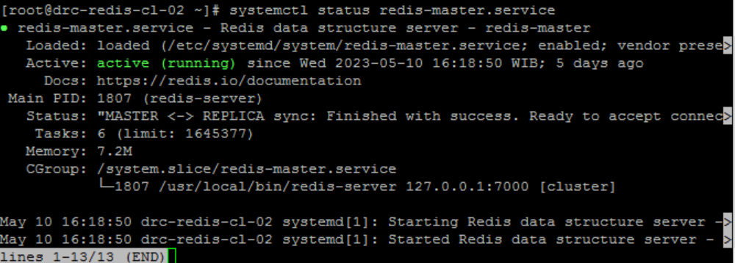

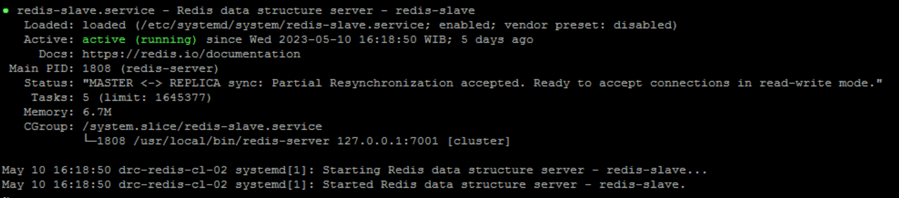

Cek openport

ss -tunlp | grep :7000

ss -tunlp | grep :7001

Output:

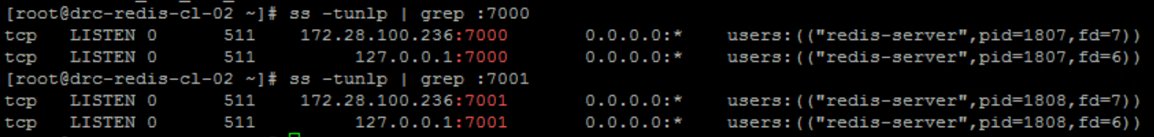

Cek replica info

redis-cli -p 7000 -a SomePassw0rd info replication

redis-cli -p 7001 -a SomePassw0rd info replication

Output:

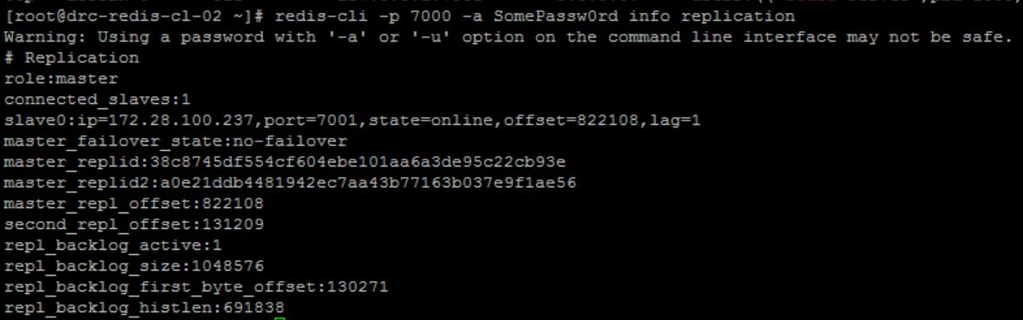

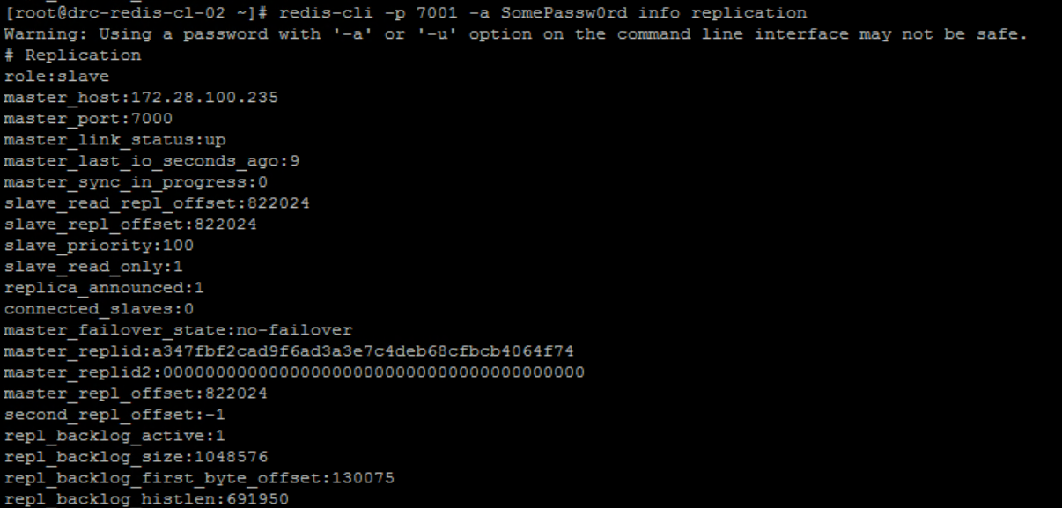

Cek cluster info

redis-cli -p 7000 -a SomePassw0rd info cluster

redis-cli -p 7001 -a SomePassw0rd info cluster

Output:

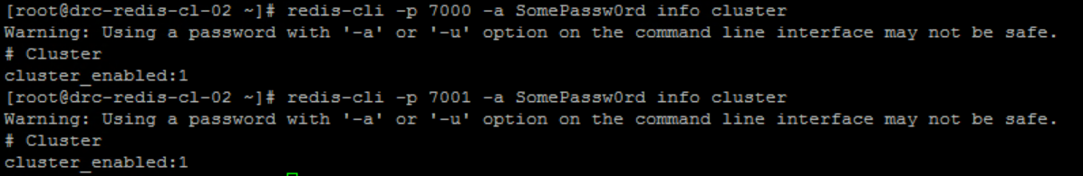

Cek node cluster

redis-cli -p 7000 -a SomePassw0rd cluster nodes

redis-cli -p 7001 -a SomePassw0rd cluster nodes

Output

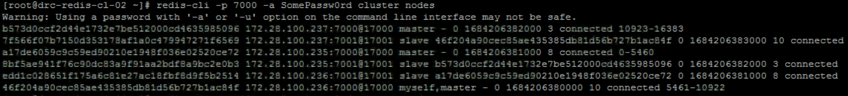

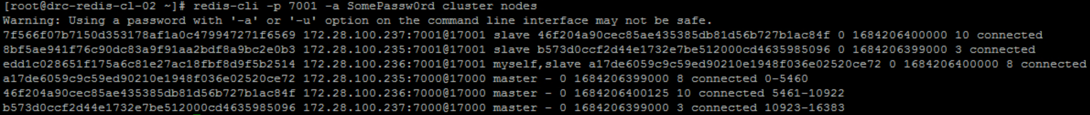

Cek logrotate

logrotate /etc/logrotate.conf --debug

Output:

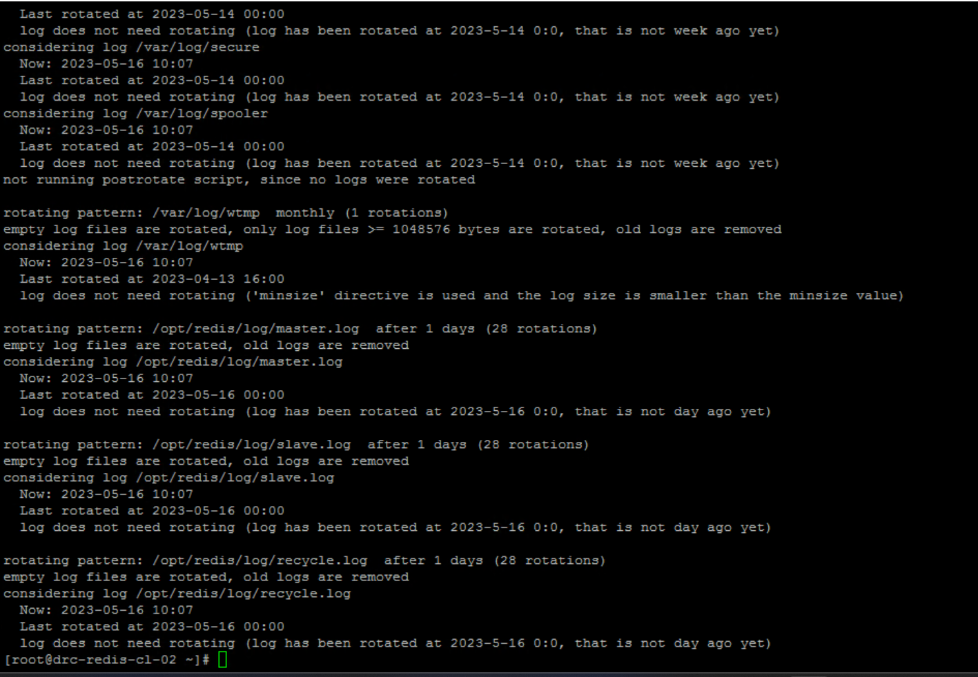

drc-redis-cl-03

Konfigurasi redis

Master.conf

|  |
| --- |
| Bind 127.0.0.1 172.28.100.237  port 7000  protected-mode no  supervised auto  pidfile /opt/redis/run/master.pid  dir /opt/redis/master  cluster-enabled yes  cluster-node-timeout 5000  loglevel verbose  logfile /opt/redis/log/master.log  requirepass SomePassw0rd  # masterauth SomePassw0rd |

Slave.conf

|  |
| --- |
| bind 127.0.0.1 172.28.100.237  protected-mode no  port 7001  supervised auto  pidfile /opt/redis/run/slave.pid  logfile /opt/redis/log/slave.log  dir /opt/redis/slave  cluster-enabled yes  cluster-config-file nodes.conf  cluster-node-timeout 5000 |

Script

#!/bin/bash

host_ip=172.28.100.237

master_port=7000

slave_port=7001

master_service_name=redis-master

slave_service_name=redis-slave

my_master_ip=172.28.100.236

my_master_port=7000

master_auth=SomePassw0rd

echo "$(date) - INFO: recycle script started"

slave_nmap=$(nmap -p $slave_port $host_ip | grep $slave_port'/tcp')

if [[ $slave_nmap == *"open"* ]]; then

  master_nmap=$(nmap -p $master_port $host_ip | grep $master_port'/tcp')

  if [[ $master_nmap == *"open"* ]]; then

    master_role=$(/usr/local/bin/redis-cli --no-auth-warning -h $host_ip -p $master_port -a $master_auth info replication | grep role)

    slave_role=$(/usr/local/bin/redis-cli --no-auth-warning -h $host_ip -p $slave_port -a $master_auth info replication | grep role)

    if [[ $slave_role == *"master"* ]] && [[ $master_role == *"master"* ]]

    then

      # echo "situasi berbahaya!"

      echo $(date) - INFO: node slave is master, cek its master status

      my_master_nmap=$(nmap -p $my_master_port $my_master_ip | grep $my_master_port'/tcp')

      if [[ $my_master_nmap == *"open"* ]]; then

        # echo "aman untuk lanjut"

        echo $(date) - INFO: node master of node slave is alive, cek its role

        my_master_role=$(/usr/local/bin/redis-cli --no-auth-warning -h $my_master_ip -p $my_master_port -a $master_auth info replication | grep role)

        if [[ $my_master_role == *"slave"* ]]; then

          # echo "hentikan service redis-slave"

          echo $(date) - INFO: node master of node slave is slave, recycle

          /usr/bin/systemctl stop $slave_service_name

          while [[ $my_master_role == *"slave"* ]]

          do

            # echo "tunggu master aktif"

            echo $(date) - INFO: recycling

            sleep 5

            my_master_role=$(/usr/local/bin/redis-cli --no-auth-warning -h $my_master_ip -p $my_master_port -a $master_auth info replication | grep role)

          done

          # echo "jalankan kembali service redis-slave"

          echo $(date) - INFO: recycled

          /usr/bin/systemctl start $slave_service_name

        fi

      else

        # echo "tidak aman untuk lanjut"

        echo $(date) - INFO: node master of node slave is down, cannot continue

      fi

    else

      # echo "situasi aman"

      echo $(date) - INFO: all good, nothing to do

    fi

  else

    # host is up, node master is down

    echo $(date) - INFO: node master is down, cannot continue

  fi

else

  # host is up, node slave is down

  echo $(date) - INFO: node slave is down, cannot continue

fi

echo $(date) - INFO: recycle script ended

chmod 0660 /opt/redis/log/recycle.log

System cek

### Cek overcomit:

|  |
| --- |
| sysctl vm.overcommit_memory vm.swappiness |

Output:



Cek network:

|  |
| --- |
| sysctl net.core.somaxconn net.ipv4.tcp_max_syn_backlog |

Output:



Redis cek

Cek versi redis

|  |
| --- |
| redis-server --version |

Ouput:



Cek status redis service:

|  |
| --- |
| systemctl status redis-master.service  systemctl status redis-slave.service |

Output:

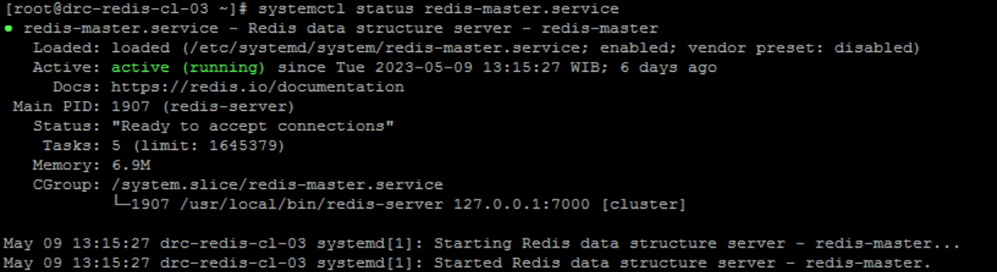

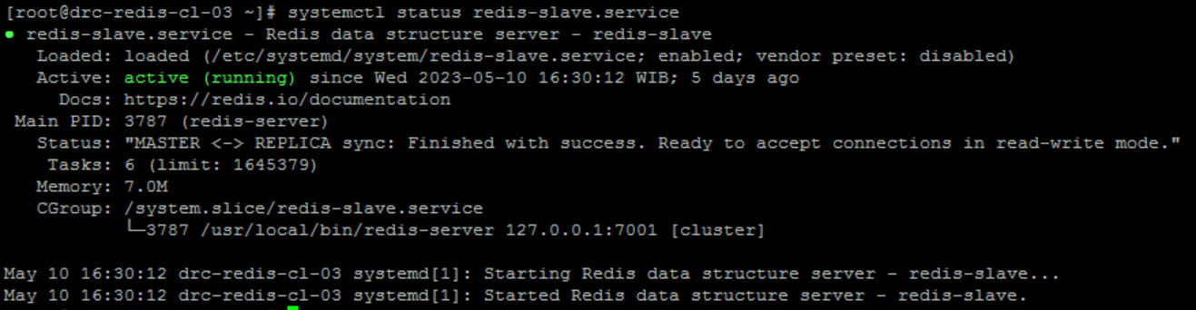

Cek openport

ss -tunlp | grep :7000

ss -tunlp | grep :7001

Output:

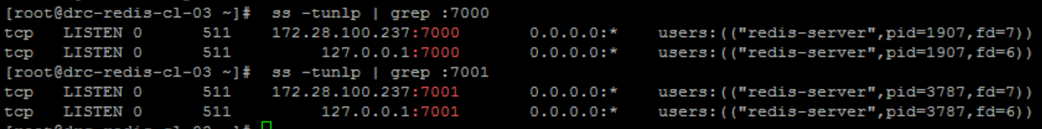

Cek replica info

redis-cli -p 7000 -a SomePassw0rd info replication

redis-cli -p 7001 -a SomePassw0rd info replication

Output:

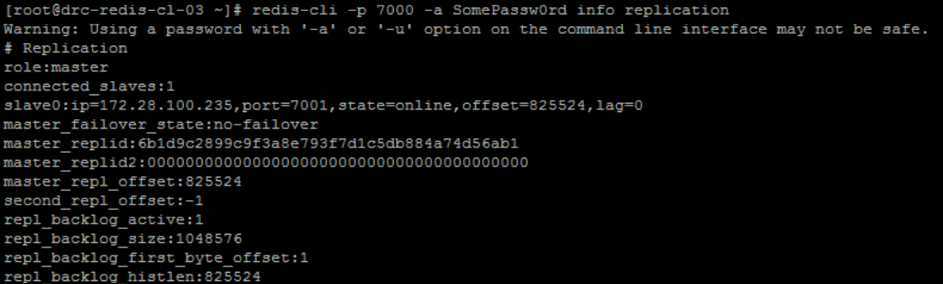

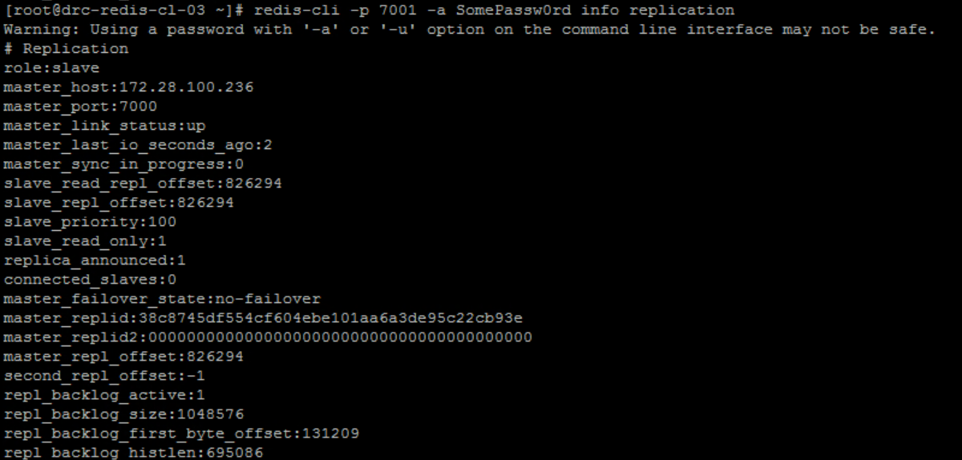

Cek cluster info

redis-cli -p 7000 -a SomePassw0rd info cluster

redis-cli -p 7001 -a SomePassw0rd info cluster

Output:

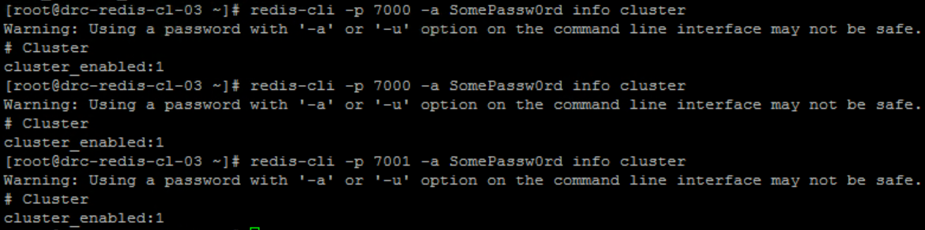

Cek node cluster

redis-cli -p 7000 -a SomePassw0rd cluster nodes

redis-cli -p 7001 -a SomePassw0rd cluster nodes

Output

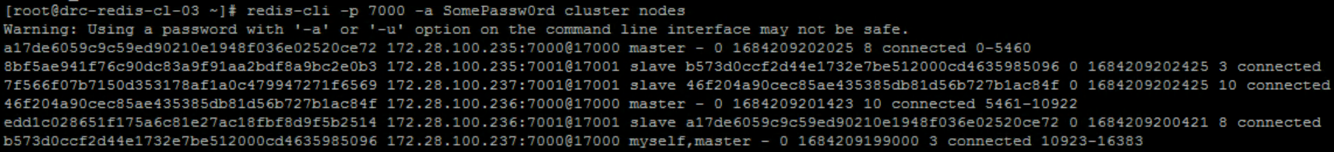

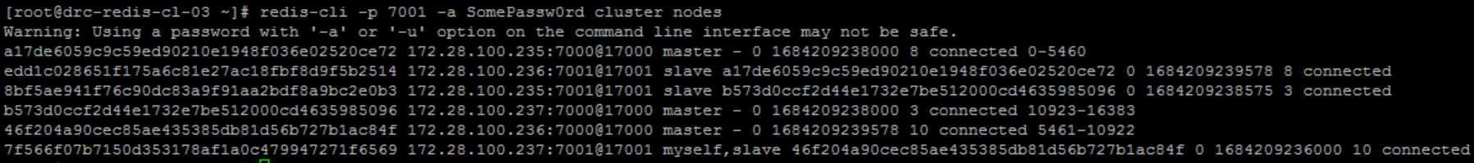

## Cek logrotate

logrotate /etc/logrotate.conf --debug

Output:

